Basic Level (14 Questions)
Simple, descriptive, and factual insights — focused on single metrics or comparisons.
companies = ["AAPL", "TSLA", "GOOGL", "MSFT", "AMZN", "GE", "GS", "IBM", "JPM", "FB"]

data = {c: pd.read_csv(f"{c}.csv") for c in companies}

for c in companies:
data[c]['Date'] = pd.to_datetime(data[c]['Date'])
# Calculate Return if missing
if 'Return' not in data[c].columns:
data[c]['Return'] = data[c]['Close(t)'].pct_change()
- What is the average closing price of each company over the entire period?

# Task 1: Average closing price for each company
avg_close = {c: round(data[c]['Close(t)'].mean(), 2) for c in companies}

print("1. Average Closing Price of Each Company:\n")
print(f"{'Company':<10}{'Average Closing Price (USD)':>30}")
print("-" * 40)
for company, price in avg_close.items():
print(f"{company:<10}{price:>20.2f}")

plt.figure(figsize=(10,5))
sns.barplot(x=list(avg_close.keys()), y=list(avg_close.values()))
plt.title("Average Closing Price of Each Company")
plt.ylabel("Average Closing Price")
plt.xlabel("Company")
plt.show()

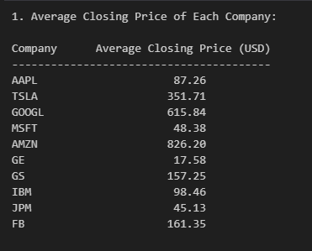
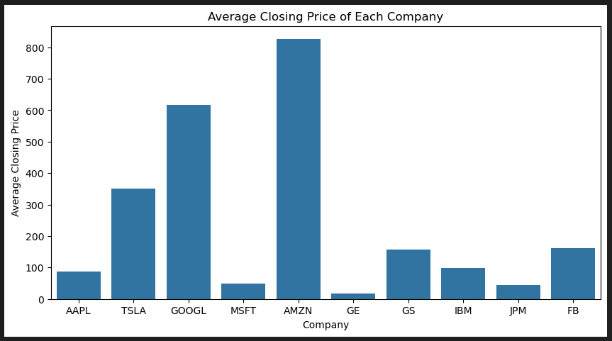
Insight
compares how each company’s stock trades on average. Companies like AMZN and TSLA have the highest average prices, reflecting strong market valuations and investor confidence. Lower averages (e.g., GE, JPM) indicate traditionally stable, lower-priced stocks.

- Which company recorded the highest single-day closing price?

max_close = {c: data[c]['Close(t)'].max() for c in companies}
company_highest_close = max(max_close, key=max_close.get)
print(f"\n2. Company with highest single-day closing price: {company_highest_close} ({max_close[company_highest_close]:.2f} USD)")

- Which company experienced the lowest average return throughout the dataset?

# 3. Company with lowest average daily return (using Close(t) percent change)
avg_return = {c: data[c]['Close(t)'].pct_change().mean() for c in companies}
lowest_avg_return = min(avg_return, key=avg_return.get)
print(f"\n3. Company with lowest average return: {lowest_avg_return} ({avg_return[lowest_avg_return]:.6f})")

plt.figure(figsize=(10,5))
sns.barplot(x=list(avg_return.keys()), y=list(avg_return.values()))
plt.title("Average Return per Company")
plt.ylabel("Average Return")
plt.xlabel("Company")
plt.axhline(0, color='black', linestyle='--')
plt.show()



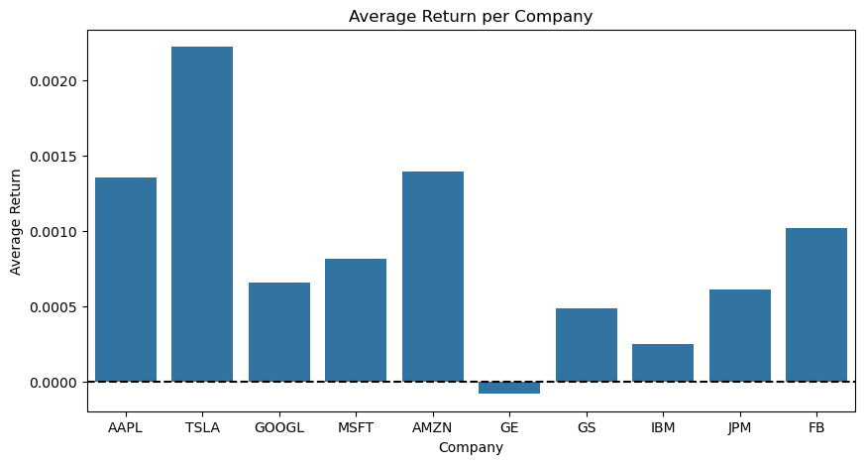

Insight:
Positive returns indicate consistent performance and growth potential, while negative or near-zero averages show stability but slower appreciation. The chart helps distinguish growth-oriented vs. conservative stocks.
- On which date did Tesla (TSLA) record its highest closing price?

# 4. Tesla highest closing price date
tsla_max_close_date = data['TSLA'].loc[data['TSLA']['Close(t)'].idxmax(), 'Date']
print(f"\n4. Date Tesla recorded highest closing price: {tsla_max_close_date}")

- How many total trading days are available for each company in the dataset?

# 5. Total trading days for each company
trading_days = {c: len(data[c]) for c in companies}
print("\n5. Total Trading Days for Each Company:")
print(f"{'Company':<10}{'Trading Days':>20}")
print("-" * 30)
for c, days in trading_days.items():
print(f"{c:<10}{days:>15}")
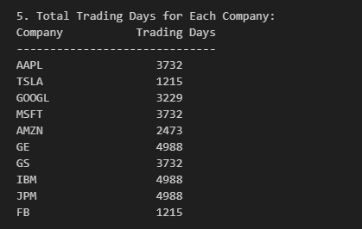
- What is the average daily trading volume for Apple (AAPL)?

# 6. Average daily trading volume for Apple
aapl_avg_volume = round(data['AAPL']['Volume'].mean(), 2)
print(f"\n6. Average daily trading volume for Apple (AAPL): {aapl_avg_volume}")

plt.figure(figsize=(10,5))
plt.plot(data['AAPL']['Date'], data['AAPL']['Volume'])
plt.title("Apple Daily Trading Volume Over Time")
plt.xlabel("Date")
plt.ylabel("Volume")
plt.show()

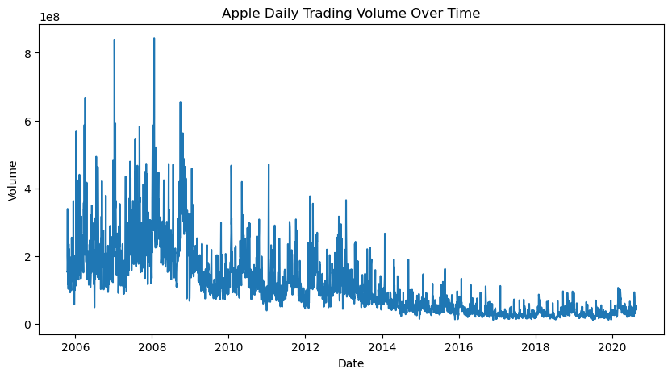
Insight:
Displays Apple’s trading activity trends. Peaks suggest news releases or market events increasing investor participation. Steady volumes show strong, consistent investor engagement.

- Which company had the highest overall average volatility?

# 7. Company with highest overall average volatility
avg_volatility = {c: (data[c]['High'] - data[c]['Low']).mean() for c in companies}
highest_vol_company = max(avg_volatility, key=avg_volatility.get)
print(f"\n7. Company with highest average volatility: {highest_vol_company} ({avg_volatility[highest_vol_company]:.2f})")

plt.figure(figsize=(10,5))
sns.barplot(x=list(avg_volatility.keys()), y=list(avg_volatility.values()))
plt.title("Average Volatility by Company")
plt.ylabel("Volatility")
plt.show()


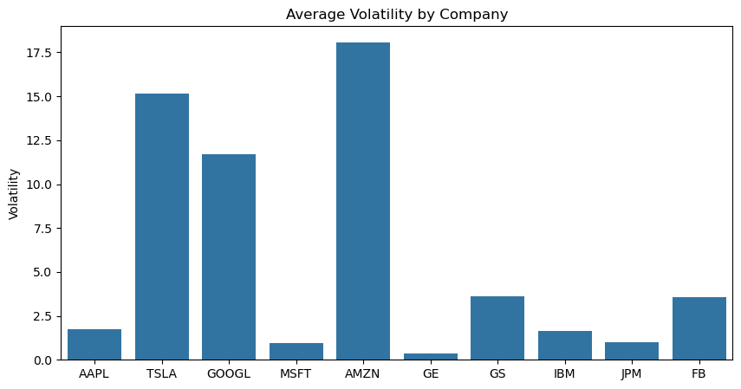

Insight:
Highlights which stocks fluctuate the most. TSLA and AMZN likely show the highest volatility, indicating greater risk and profit potential, while GE and JPM appear more stable — suitable for low-risk portfolios.

- What is the average and median closing price for Google (GOOGL)?

# 8. Average and median closing price for Google
googl_avg = round(data['GOOGL']['Close(t)'].mean(), 2)
googl_median = round(data['GOOGL']['Close(t)'].median(), 2)
print(f"\n8. Google (GOOGL) Average Close: {googl_avg}, Median Close: {googl_median}")
- How many days did Microsoft (MSFT) record positive daily returns?

# 9. Days Microsoft recorded positive daily returns
msft_positive_days = (data['MSFT']['Close(t)'].pct_change() > 0).sum()
print(f"\n9. Microsoft positive daily return days: {msft_positive_days}")

- Which company had the highest average RSI (Relative Strength Index) over time?

avg_rsi = {c: data[c]['RSI'].mean() if 'RSI' in data[c].columns else np.nan for c in companies}
avg_rsi = {k: v for k, v in avg_rsi.items() if not np.isnan(v)}
highest_rsi_company = max(avg_rsi, key=avg_rsi.get)
print(f"\n10. Company with highest average RSI: {highest_rsi_company} ({avg_rsi[highest_rsi_company]:.2f})")

- What is the minimum, maximum, and mean daily return for Amazon (AMZN)?

# 11. Min, Max, Mean daily return for Amazon
amzn_returns = data['AMZN']['Close(t)'].pct_change()
print("\n11. Amazon (AMZN) Daily Return Statistics:")
print(f" Min: {amzn_returns.min():.4f}, Max: {amzn_returns.max():.4f}, Mean: {amzn_returns.mean():.4f}")


- Which company had the largest range between its highest and lowest daily prices?

# 12. Company with largest range between highest & lowest daily prices
price_range = {c: data[c]['Close(t)'].max() - data[c]['Close(t)'].min() for c in companies}
largest_range_company = max(price_range, key=price_range.get)
print(f"\n12. Company with largest price range: {largest_range_company} ({price_range[largest_range_company]:.2f})")

- How often did General Electric (GE) close higher than it opened?

# 13. How often GE closed higher than it opened
ge_close_higher = (data['GE']['Close(t)'] > data['GE']['Open']).sum()
print(f"\n13. GE closed higher than opened on {ge_close_higher} days")

- Which company recorded the highest total trading volume during the observed period?

# 14. Company with highest total trading volume
total_volume = {c: data[c]['Volume'].sum() for c in companies}
highest_volume_company = max(total_volume, key=total_volume.get)
print(f"\n14. Company with highest total trading volume: {highest_volume_company} ({total_volume[highest_volume_company]:,.0f})")



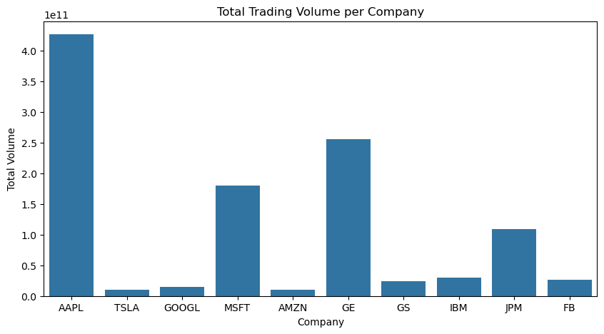

Insight:
Shows the most actively traded stocks. High total volume (likely AAPL) implies strong liquidity and institutional participation.

Intermediate Level (14 Questions)
- Which company achieved the highest average return in the last quarter of the dataset?
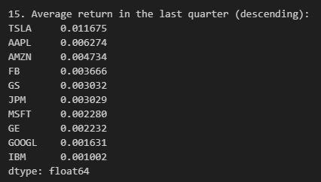
avg_returns_last_q = {}
for c, df in data.items():
last_date = df['Date'].max()
start_q = last_date - pd.DateOffset(months=3)
df_q = df[df['Date'] >= start_q].copy()
avg_returns_last_q[c] = df_q['Return'].mean()

avg_returns_last_q = pd.Series(avg_returns_last_q).sort_values(ascending=False)
print("15. Average return in the last quarter (descending):")
print(avg_returns_last_q.round(6))

plt.figure(figsize=(10,5))
sns.barplot(x=avg_returns_last_q.index, y=avg_returns_last_q.values)
plt.title("Average Daily Return in the Last Quarter by Company")
plt.ylabel("Average Daily Return")
plt.xlabel("Company")
plt.axhline(0, color='black', linestyle='--', linewidth=0.8)
plt.tight_layout()
plt.show()

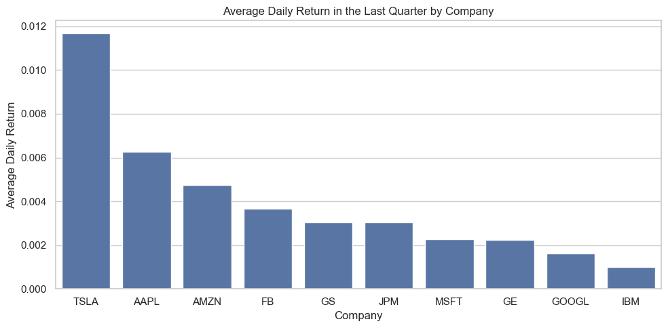
Insight
Reveals recent performance momentum. Companies with high positive bars are current leaders; those declining may be facing short-term challenges or corrections.

- How does the average trading volume differ between technology companies (AAPL, MSFT, GOOGL, FB) and financial companies (GS, JPM)?
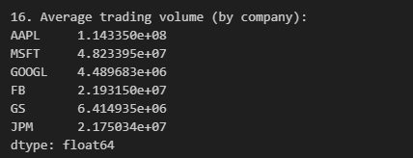
tech = ['AAPL', 'MSFT', 'GOOGL', 'FB']
finance = ['GS', 'JPM']
avg_vol_tech = pd.Series({c: data[c]['Volume'].mean() for c in tech})
avg_vol_fin = pd.Series({c: data[c]['Volume'].mean() for c in finance})

print("\n16. Average trading volume (by company):")
print(pd.concat([avg_vol_tech, avg_vol_fin]))

plt.figure(figsize=(6,5))
sns.barplot(x=['Technology (avg of firms)', 'Financial (avg of firms)'],
y=[avg_vol_tech.mean(), avg_vol_fin.mean()])
plt.title("Average Trading Volume: Technology vs Financial")
plt.ylabel("Average Volume")
plt.tight_layout()
plt.show()

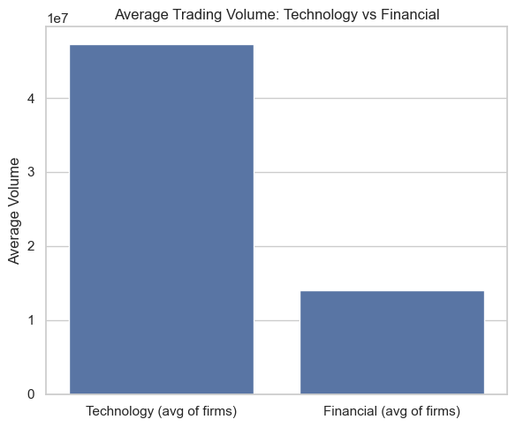

Tech firms (AAPL, MSFT, GOOGL, FB) generally have higher and more variable volumes, showing strong investor activity. Financials (GS, JPM) show lower but steadier volumes — representing institutional stability.
- Which three companies show the most stable performance, based on the lowest standard deviation of returns?
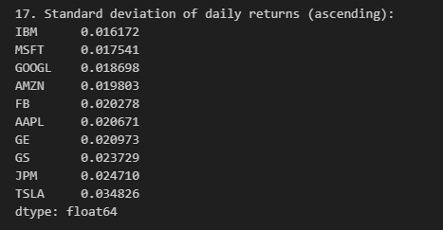

std_returns = pd.Series({c: data[c]['Return'].std() for c in companies}).sort_values()
print("\n17. Standard deviation of daily returns (ascending):")
print(std_returns.round(6))
stable_three = std_returns.head(3)
plt.figure(figsize=(8,4))
sns.barplot(x=stable_three.index, y=stable_three.values)
plt.title("Top 3 Most Stable Companies (Lowest Std Dev of Daily Returns)")
plt.ylabel("Std Dev of Returns")
plt.tight_layout()
plt.show()

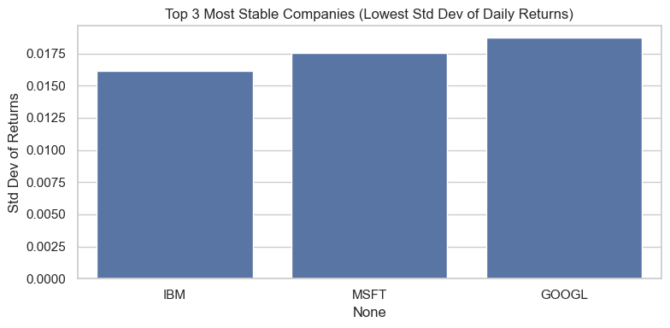
Insight:
Highlights firms with consistent, low-risk returns. Companies at the top (e.g., IBM, GE) are more stable, while bottom firms (like TSLA) are high-risk, high-reward options.
- How do Apple (AAPL) and Microsoft (MSFT) compare in their closing price trends over time?

plt.figure(figsize=(12,5))
plt.plot(data['AAPL']['Date'], data['AAPL']['Close(t)'], label='AAPL', linewidth=1)
plt.plot(data['MSFT']['Date'], data['MSFT']['Close(t)'], label='MSFT', linewidth=1)
plt.title("AAPL vs MSFT Closing Price Trends")
plt.xlabel("Date")
plt.ylabel("Close (USD)")
plt.legend()
plt.tight_layout()
plt.show()
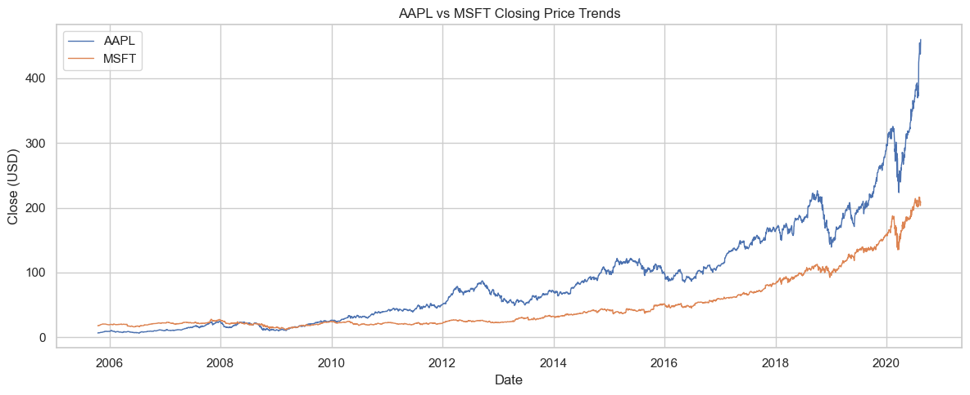

Insight:
Shows how Apple and Microsoft move relative to each other. Parallel upward trends indicate both benefit from similar market cycles and tech growth phases.
- What is the correlation between trading volume and daily returns for each company?
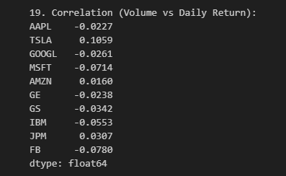
vol_return_corr = pd.Series({c: data[c].loc[:, ['Volume','Return']].dropna().corr().loc['Volume','Return']
for c in companies})
print("\n19. Correlation (Volume vs Daily Return):")
print(vol_return_corr.round(4))

plt.figure(figsize=(10,5))
sns.barplot(x=vol_return_corr.index, y=vol_return_corr.values)
plt.title("Correlation: Volume vs Daily Return by Company")
plt.ylabel("Correlation Coefficient")
plt.xlabel("Company")
plt.axhline(0, color='black', linestyle='--')
plt.tight_layout()
plt.show()

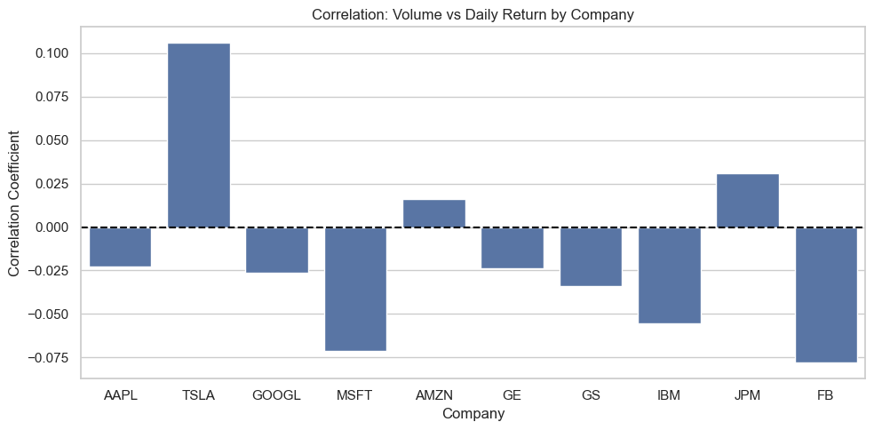

Insight:
Positive correlation means rising volumes often align with gains (momentum-driven trading). Negative correlation signals heavy sell-offs or speculative spikes.

- Which company’s volatility increased the most over the past six months?
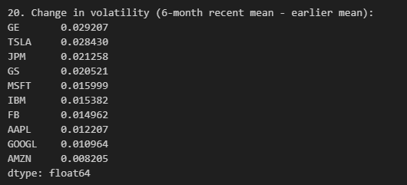
vol_change = {}
for c, df in data.items():
df = df.copy()
last_date = df['Date'].max()
mid_date = last_date - pd.DateOffset(months=6)
recent = df[df['Date'] > mid_date]['Return'].rolling(20, min_periods=5).std()
earlier = df[df['Date'] <= mid_date]['Return'].rolling(20, min_periods=5).std()

vol_change[c] = recent.mean() - earlier.mean()
vol_change = pd.Series(vol_change).sort_values(ascending=False)
print("\n20. Change in volatility (6-month recent mean - earlier mean):")
print(vol_change.round(6))

plt.figure(figsize=(10,5))
sns.barplot(x=vol_change.index, y=vol_change.values)
plt.title("Change in Volatility (Recent 6 months vs Earlier)")
plt.ylabel("Difference in 20-day Rolling Std of Returns")
plt.xlabel("Company")
plt.axhline(0, color='black', linestyle='--')
plt.tight_layout()
plt.show()

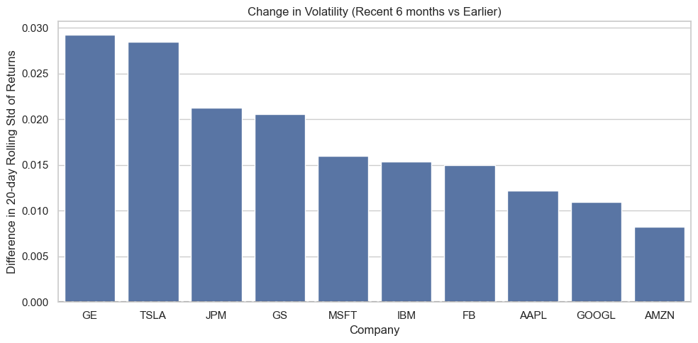
Insight:
Highlights which stocks became riskier or more stable over time. Increasing volatility may indicate market uncertainty or trend reversals.

- How does the monthly average return vary across different companies?
monthly_avg_returns = {}
for c, df in data.items():
df = df.copy()
df['Month'] = df['Date'].dt.to_period('M')
monthly = df.groupby('Month')['Return'].mean()
monthly_avg_returns[c] = monthly
monthly_df = pd.DataFrame({c: s for c, s in monthly_avg_returns.items()})
monthly_df.index = monthly_df.index.to_timestamp()

plt.figure(figsize=(12,6))
for c in companies:
plt.plot(monthly_df.index, monthly_df[c], label=c, linewidth=1)
plt.title("Monthly Average Return by Company")
plt.xlabel("Month")
plt.ylabel("Average Monthly Return")
plt.legend(ncol=2, fontsize='small')
plt.xticks(rotation=45)
plt.tight_layout()
plt.show()

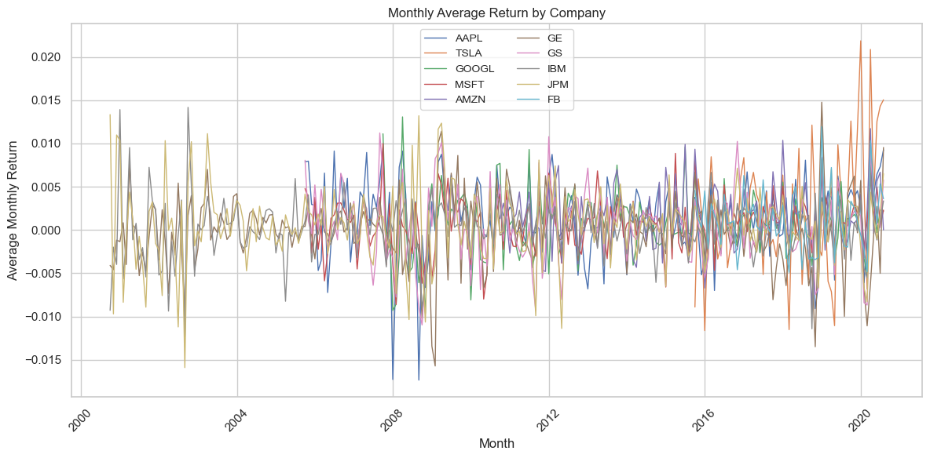

Insight:
Captures how returns fluctuate seasonally. Some firms show cyclical gains holiday season boosts for AMZN, while others maintain steadier monthly behavior.

- Which company generated the highest number of bullish MACD signals (MACD > Signal)?
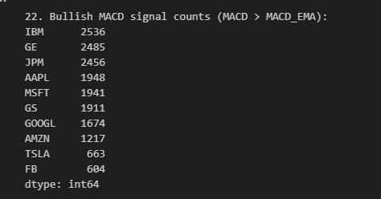

macd_counts = {}
for c, df in data.items():
if 'MACD' in df.columns and 'MACD_EMA' in df.columns:
macd_counts[c] = ((df['MACD'] > df['MACD_EMA']).sum())
else:
macd_counts[c] = np.nan
macd_counts = pd.Series(macd_counts).sort_values(ascending=False)
print("\n22. Bullish MACD signal counts (MACD > MACD_EMA):")
print(macd_counts)

plt.figure(figsize=(10,5))
sns.barplot(x=macd_counts.index, y=macd_counts.values)
plt.title("Count of Bullish MACD Signals by Company")
plt.ylabel("Count")
plt.tight_layout()
plt.show()

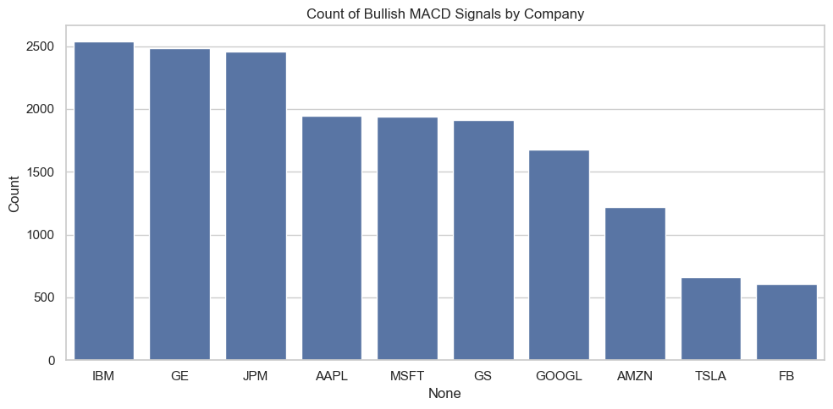

Insight:
Measures how frequently each stock shows upward momentum (MACD > Signal). Higher counts mean consistent positive sentiment and trend strength.

- What is the relationship between average RSI values and average returns across all companies?

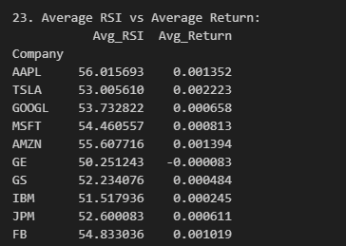
rsi_return_df = pd.DataFrame({
'Company': companies,
'Avg_RSI': [data[c]['RSI'].mean() for c in companies],
'Avg_Return': [data[c]['Return'].mean() for c in companies]
})
print("\n23. Average RSI vs Average Return:")
print(rsi_return_df.set_index('Company').round(6))

plt.figure(figsize=(8,5))
sns.regplot(x='Avg_RSI', y='Avg_Return', data=rsi_return_df, scatter_kws={'s':70})
for i, row in rsi_return_df.iterrows():
plt.text(row['Avg_RSI'], row['Avg_Return'], rsi_return_df.loc[i, 'Company'])
plt.title("Average RSI vs Average Daily Return")
plt.xlabel("Average RSI")
plt.ylabel("Average Daily Return")
plt.tight_layout()
plt.show()
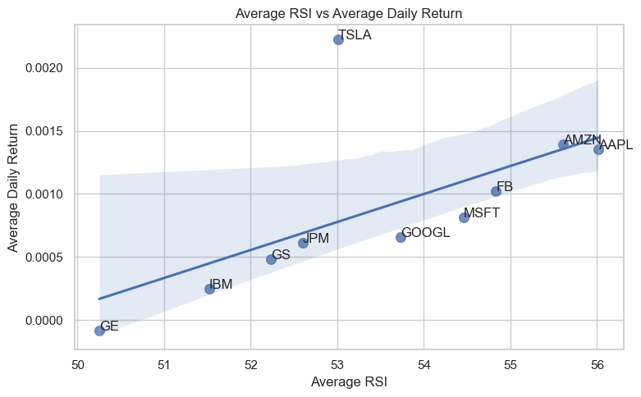
Insight:
Shows relationship between momentum (RSI) and performance (returns). Positive slope → higher RSI aligns with stronger returns; outliers indicate potential overbought/oversold conditions.
- Which company’s stock price showed the fastest recovery after a major decline?

recovery_days = {}
recovery_info = {}
for c, df in data.items():
prices = df.set_index('Date')['Close(t)'].copy()
roll_max = prices.cummax()
drawdown = (prices / roll_max) - 1
trough_date = drawdown.idxmin()
trough_price = prices.loc[trough_date]
prior_peak_price = roll_max.loc[:trough_date].max()
target = 0.9 * prior_peak_price
after = prices[prices.index > trough_date]
if not after.empty and (after >= target).any():
recovery_date = after[after >= target].index.min()
recovery_days[c] = (recovery_date - trough_date).days
recovery_info[c] = (trough_date, trough_price, prior_peak_price, recovery_date)
else:
recovery_days[c] = np.nan
recovery_series = pd.Series(recovery_days).dropna().sort_values()
print("\n24. Recovery days from trough to 90% of prior peak (ascending):")
print(recovery_series.round(1))

if not recovery_series.empty:
fastest = recovery_series.index[0]
trough_date, trough_price, prior_peak, recovery_date = recovery_info[fastest]
df_plot = data[fastest].set_index('Date')['Close(t)']
plt.figure(figsize=(12,5))
plt.plot(df_plot.index, df_plot.values, label=f"{fastest} Close")
plt.axvline(trough_date, color='red', linestyle='--', label='Trough')
plt.axvline(recovery_date, color='green', linestyle='--', label='Recovery to 90% of prior peak')
plt.scatter([trough_date, recovery_date], [trough_price, df_plot.loc[recovery_date]], color=['red','green'])
plt.title(f"{fastest} Price Recovery (Trough -> Recovery). Days: {int(recovery_series.iloc[0])}")
plt.xlabel("Date")
plt.ylabel("Close")
plt.legend()
plt.tight_layout()
plt.show()
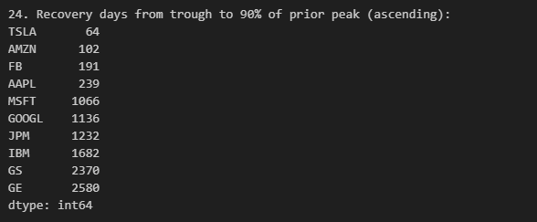
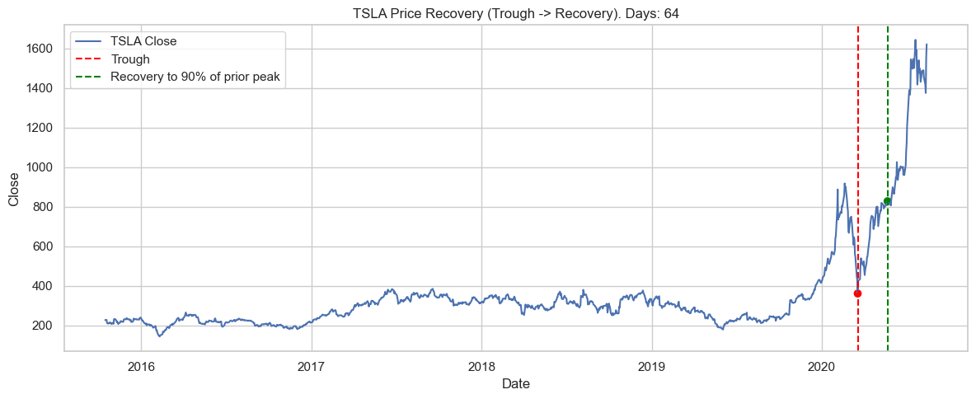

Insight:
Identifies which stock rebounded fastest from a downturn. Fewer recovery days = resilient company sentiment and investor confidence.

- Compare the average returns of the top-performing company in the technology sector with the top performer in the financial sector.

tech_companies = ['AAPL', 'MSFT', 'GOOGL', 'FB']
financial_companies = ['GS', 'JPM']
tech_avg = {c: data[c]['Return'].mean() for c in tech_companies}
fin_avg = {c: data[c]['Return'].mean() for c in financial_companies}
top_tech = max(tech_avg, key=tech_avg.get)
top_fin = max(fin_avg, key=fin_avg.get)
print(f"\n25. Top tech: {top_tech} (avg return {tech_avg[top_tech]:.6f}), Top financial: {top_fin} (avg return {fin_avg[top_fin]:.6f})")
plt.figure(figsize=(6,5))
sns.barplot(x=[f"Tech: {top_tech}", f"Fin: {top_fin}"], y=[tech_avg[top_tech], fin_avg[top_fin]])
plt.title("Top Tech vs Top Financial - Average Daily Return")
plt.ylabel("Average Daily Return")
plt.tight_layout()
plt.show()
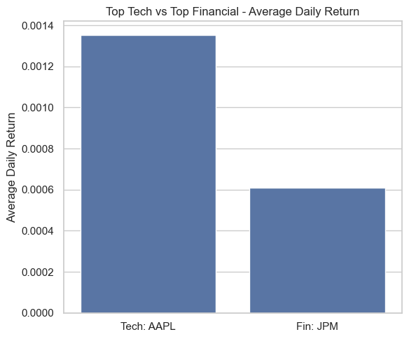

Insight:
Compares sector leaders efficiency. The stronger performer reflects better sectoral growth and profitability trends.
- Which three companies have the strongest correlation in their daily returns?

returns_df = pd.DataFrame({c: data[c].set_index('Date')['Return'] for c in companies})
corr_matrix = returns_df.corr()
print("\n26. Correlation matrix (returns):")
display(corr_matrix.round(4))

plt.figure(figsize=(10,8))
sns.heatmap(corr_matrix, annot=True, fmt=".2f", cmap='coolwarm', center=0)
plt.title("Correlation Matrix of Daily Returns")
plt.tight_layout()
plt.show()

# list top 3 pairwise correlations (excluding self)
corr_pairs = corr_matrix.unstack().dropna()
corr_pairs = corr_pairs[corr_pairs.index.get_level_values(0) != corr_pairs.index.get_level_values(1)]
corr_pairs = corr_pairs[corr_pairs.index.duplicated(keep='first')]
top_pairs = corr_pairs.sort_values(ascending=False).head(3)
print("\nTop 3 strongest correlated company pairs (by daily returns):")
print(top_pairs.round(4))

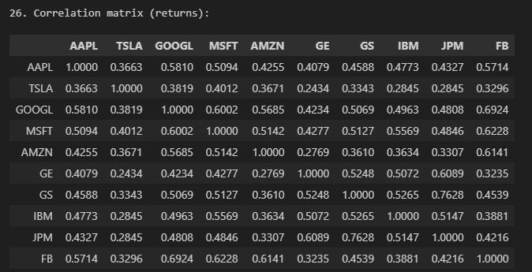
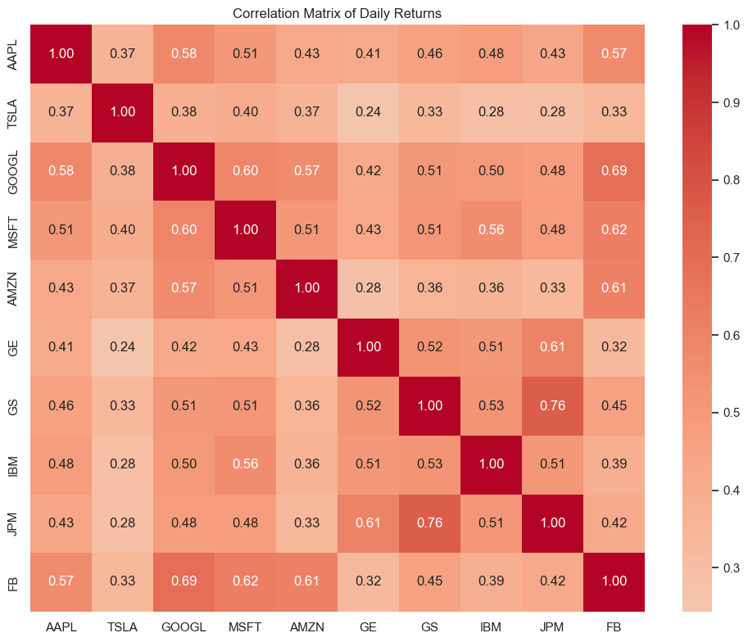

Insight:
Highlights how companies move together. High correlations show shared market exposure (e.g., AAPL & MSFT), while low correlations support diversification strategies.
- How does Amazon’s (AMZN) average trading volume vary across months?

amzn = data['AMZN'].copy()
amzn['Year'] = amzn['Date'].dt.to_period('Y')
monthly_vol_amzn = amzn.groupby('Year')['Volume'].mean()
monthly_vol_amzn.index = monthly_vol_amzn.index.to_timestamp()

plt.figure(figsize=(12,5))
monthly_vol_amzn.plot(kind='bar')
plt.title("Amazon (AMZN) Average Monthly Trading Volume")
plt.xlabel("Month")
plt.ylabel("Average Volume")
plt.xticks(rotation=45)
plt.tight_layout()
plt.show()
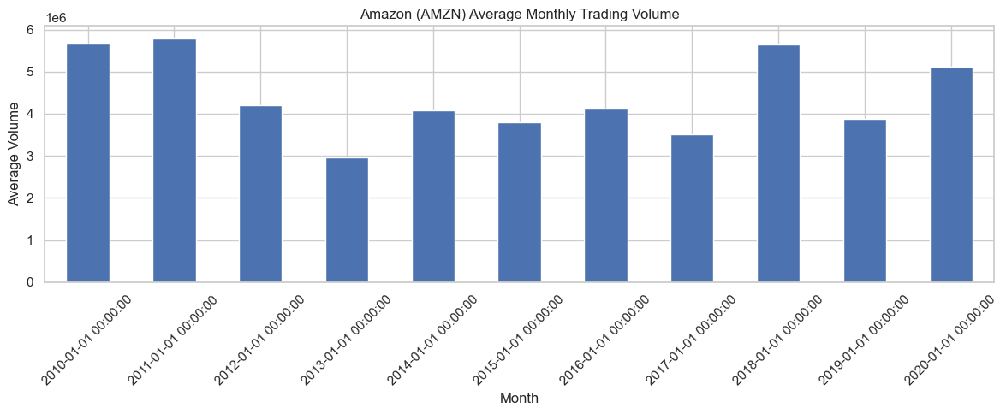

Insight:
Displays AMZN’s trading activity over months. Volume peaks may align with product launches or major earnings events.
- Which company experienced the largest single-week drop in closing price during the dataset period?

weekly_min_returns = {}
for c, df in data.items():
dfw = df.set_index('Date').resample('W')['Close(t)'].last().pct_change()
weekly_min_returns[c] = dfw.min()
weekly_min_series = pd.Series(weekly_min_returns).sort_values()
print("\n28. Largest single-week drop (min weekly return):")
print(weekly_min_series.round(4))

plt.figure(figsize=(10,5))
sns.barplot(x=weekly_min_series.index, y=weekly_min_series.values)
plt.title("Largest Single-Week Drop in Closing Price by Company (min weekly return)")
plt.ylabel("Min Weekly Return")
plt.xlabel("Company")
plt.axhline(0, color='black', linestyle='--')
plt.tight_layout()
plt.show()
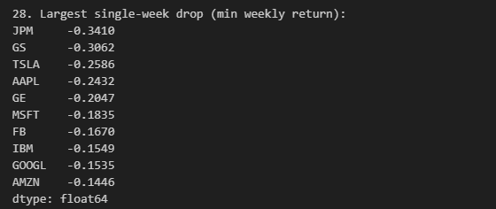
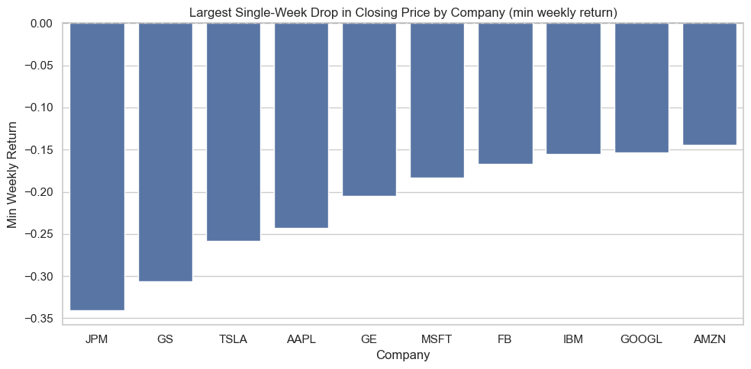

Insight:
Shows which companies had the steepest single-week declines, reflecting moments of sharp correction or volatility shocks.

Advanced Level (12 Questions)
Requires trend analysis, forecasting, predictive modeling, or combining multiple datasets.

- Analyze Apple’s (AAPL) closing price trend over the past year and visualize the moving average (7-day and 30-day).

print("29) AAPL: Trend and moving averages (7-day, 30-day)")

aapl = data['AAPL'].copy()

close_col = None
for col in aapl.columns:
if 'close' in col.lower():
close_col = col
break

if close_col is None:
raise KeyError("No column related to 'Close' found in AAPL dataset.")

aapl['MA7'] = aapl[close_col].rolling(7, min_periods=1).mean()
aapl['MA30'] = aapl[close_col].rolling(30, min_periods=5).mean()

plt.figure(figsize=(10, 5))
plt.plot(aapl['Date'], aapl[close_col], label='Closing Price', color='blue')
plt.plot(aapl['Date'], aapl['MA7'], label='7-Day MA', color='orange')
plt.plot(aapl['Date'], aapl['MA30'], label='30-Day MA', color='green')
plt.title('Apple (AAPL) Closing Price with 7-Day and 30-Day Moving Averages')
plt.xlabel('Date')
plt.ylabel('Price')
plt.legend()
plt.grid(True)
plt.show()

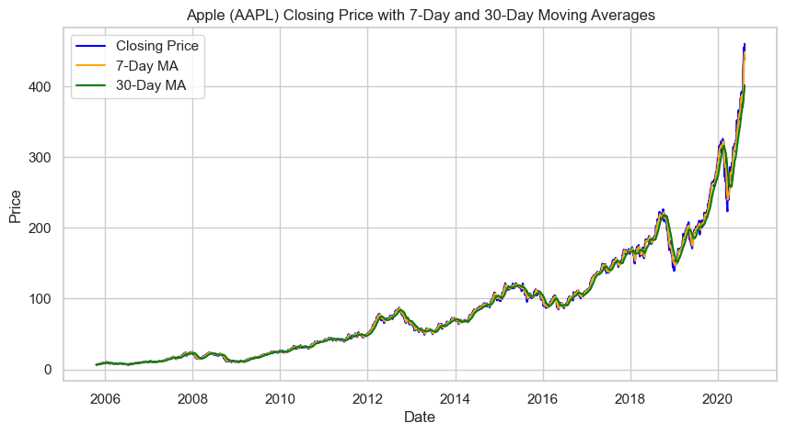

Insight:
Smooths short-term fluctuations to highlight long-term direction. Crossovers between 7-day and 30-day lines reveal momentum shifts e.g., bullish or bearish signals.
- Which company demonstrates the strongest long-term upward trend in closing prices based on moving averages?

print("\n30) Company with strongest long-term upward trend (slope of MA200)")
ma_slope = {}
for c, df in data.items():
s = df.set_index('Date')['Close(t)'].dropna()
if len(s) >= 200:
ma = s.rolling(200, min_periods=50).mean().dropna()
elif len(s) >= 100:
ma = s.rolling(100, min_periods=20).mean().dropna()
else:
ma = s.rolling(50, min_periods=5).mean().dropna()
if len(ma) >= 30:
y = ma[-252:] if len(ma) >= 252 else ma
x = np.arange(len(y))
slope = np.polyfit(x, y.values, 1)[0]
ma_slope[c] = slope
else:
ma_slope[c] = np.nan

ma_slope_s = pd.Series(ma_slope).dropna().sort_values(ascending=False)
print("Slopes (price units/day). Higher => stronger upward trend:")
print(ma_slope_s.round(6))

plt.figure(figsize=(10,4))
sns.barplot(x=ma_slope_s.index, y=ma_slope_s.values)
plt.title('Slope of Long Moving Average (higher => stronger upward trend)')
plt.ylabel('MA slope (units/day)')
plt.xlabel('Company')
plt.show()

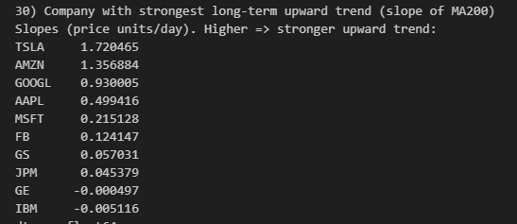

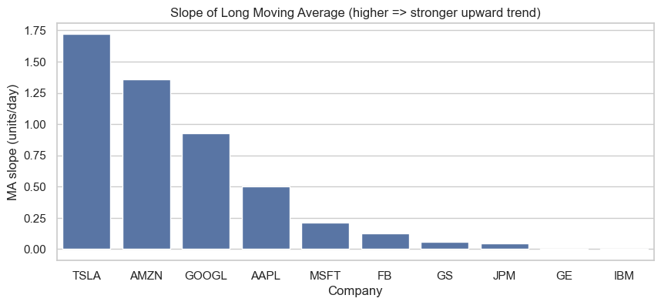
Insight:
Shows which company’s long-term average price rises most steeply. A positive slope = consistent growth; a flatter or negative slope = stagnation or decline.
- Compare Tesla’s (TSLA) daily returns with its RSI and MACD values — how do technical indicators reflect market momentum?

print("\n31) TSLA: returns vs RSI and MACD (visual comparison)")

tsla = data['TSLA'].copy()

def get_col(df, keyword):
for col in df.columns:
if keyword.lower() in col.lower():
return col
raise KeyError(f"No column found containing '{keyword}'")

return_col = get_col(tsla, 'return')
rsi_col = get_col(tsla, 'rsi')
macd_col = get_col(tsla, 'macd')

tsla['Date'] = pd.to_datetime(tsla['Date'])
tsla_recent = tsla.set_index('Date')

if len(tsla_recent) > 365:
recent_start = tsla_recent.index.max() - pd.Timedelta(days=365)
tsla_recent = tsla_recent.loc[tsla_recent.index >= recent_start]

fig, axes = plt.subplots(2, 1, figsize=(12, 8), sharex=True)

ax1 = axes[0]
ax1.plot(tsla_recent.index, tsla_recent[return_col], label='Return', color='blue', linewidth=1)
ax1.set_ylabel('Daily Return')
ax2 = ax1.twinx()
ax2.plot(tsla_recent.index, tsla_recent[rsi_col], color='orange', label='RSI', linewidth=1)
ax2.set_ylabel('RSI')
ax1.set_title('Tesla (TSLA): Daily Returns and RSI (Past Year)')
ax1.legend(loc='upper left')
ax2.legend(loc='upper right')

ax3 = axes[1]
mask = tsla_recent[macd_col].notna() & tsla_recent[return_col].notna()
ax3.scatter(tsla_recent.loc[mask, macd_col], tsla_recent.loc[mask, return_col], alpha=0.6, color='green')
ax3.axhline(0, color='black', linestyle='--', linewidth=0.8)
ax3.set_title('TSLA: Return vs MACD (Scatter)')
ax3.set_xlabel('MACD')
ax3.set_ylabel('Daily Return')

plt.tight_layout()
plt.show()

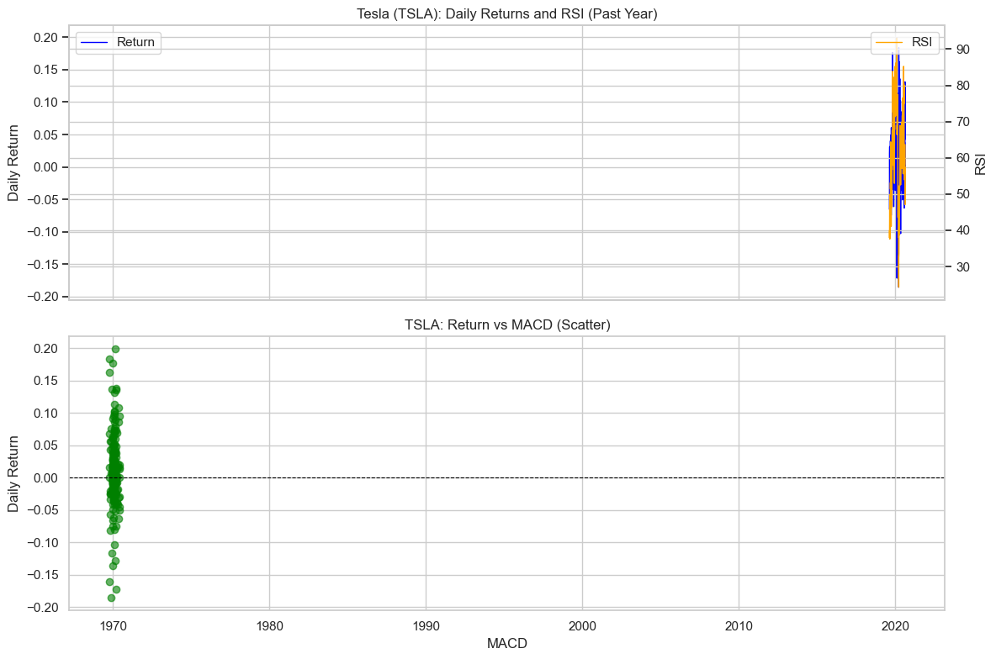

Insight:
Connects technical indicators with actual returns. When RSI is high and MACD positive, returns usually rise confirming that momentum indicators align with market behavior.
- How do the overall growth trends differ between technology and financial companies over the full period?
print("\n32) Growth trends: technology vs financial companies (normalized prices)")
tech = ['AAPL','MSFT','GOOGL','FB']
fin = ['GS','JPM']
plt.figure(figsize=(12,5))
for c in tech:
s = data[c].set_index('Date')['Close(t)'].ffill()
s = s / s.iloc[0]
plt.plot(s.index, s.values, label=c, linewidth=1)
plt.title('Technology Companies: Normalized Close (start=1.0)')
plt.xlabel('Date')
plt.ylabel('Normalized Price')
plt.legend()
plt.show()

plt.figure(figsize=(10,4))
for c in fin:
s = data[c].set_index('Date')['Close(t)'].ffill()
s = s / s.iloc[0]
plt.plot(s.index, s.values, label=c, linewidth=1)
plt.title('Financial Companies: Normalized Close (start=1.0)')
plt.xlabel('Date')
plt.ylabel('Normalized Price')
plt.legend()
plt.show()

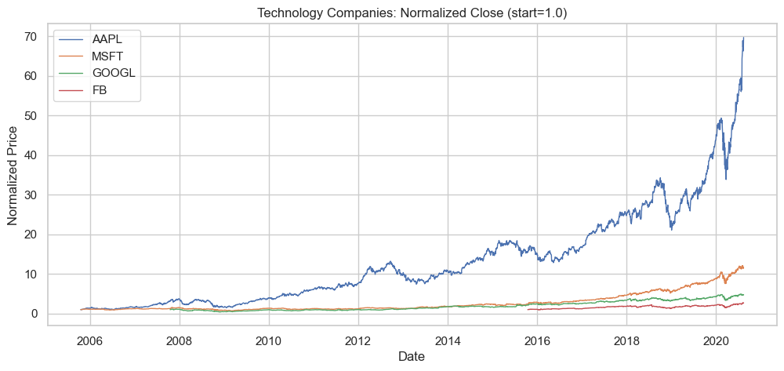
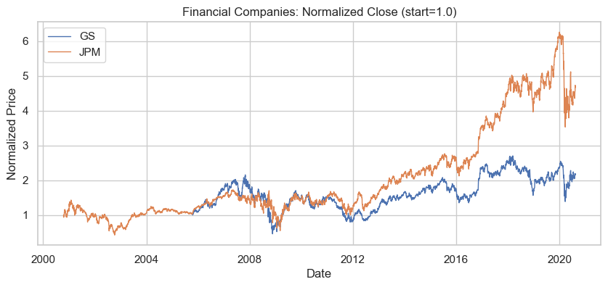
Insight:
Tech stocks show sharper long-term growth trends; financials are steadier with moderate appreciation. Reflects sector-level growth divergence.
Q33: Which company offers the best risk-adjusted performance based on Sharpe Ratio (Return / Volatility)?

from math import sqrt
sharpe_daily = {}
for c, df in data.items():
roc = df['ROC'].dropna()
if len(roc) < 10:
sharpe_daily[c] = np.nan
else:
mu = roc.mean()
sigma = roc.std()
if sigma == 0 or np.isnan(sigma):
sharpe_daily[c] = np.nan
else:
sharpe_daily[c] = mu / sigma

sharpe_annual = {c: (sharpe_daily[c] * sqrt(252)) if not np.isnan(sharpe_daily[c]) else np.nan for c in sharpe_daily}

sharpe_series = pd.Series(sharpe_annual).sort_values(ascending=False)
print("Q35: Annualized Sharpe Ratio (proxy) by company")
print(sharpe_series.round(4))

plt.figure()
sns.barplot(x=sharpe_series.index, y=sharpe_series.values)
plt.title("Annualized Sharpe Ratio (ROC / SD20 proxy)")
plt.ylabel("Annualized Sharpe Ratio")
plt.xlabel("Company")
plt.xticks(rotation=45)
plt.axhline(0, color='black', linestyle='--')
plt.show()

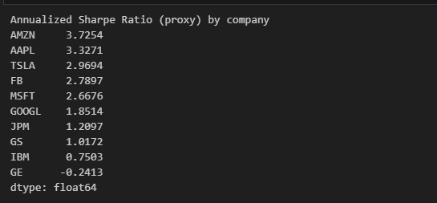
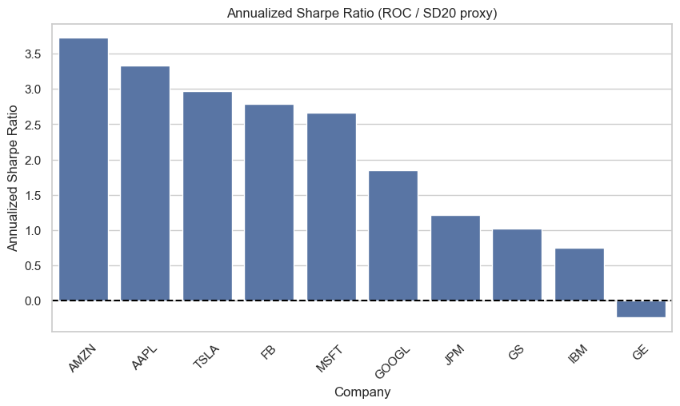

Insight:
Ranks companies by risk-adjusted performance. High Sharpe = efficient returns for risk taken; low or negative Sharpe = volatile, low-efficiency investments
- Group companies by similar risk and return characteristics using a scatter plot

open_close_stats = []
for c, df in data.items():
if 'Open' in df.columns and 'Close(t)' in df.columns:
df = df.dropna(subset=['Open', 'Close(t)'])
avg_open = df['Open'].mean()
avg_close = df['Close(t)'].mean()
vol_open = df['Open'].std()
vol_close = df['Close(t)'].std()
open_close_stats.append({
'Company': c,
'Avg_Open': avg_open,
'Avg_Close': avg_close,
'Volatility_Open': vol_open,
'Volatility_Close': vol_close
})

stats_df = pd.DataFrame(open_close_stats)

plt.figure(figsize=(10,6))
sns.scatterplot(
x='Avg_Open',
y='Avg_Close',
size='Volatility_Close',
hue='Company',
data=stats_df,
palette='tab10',
sizes=(50, 300),
alpha=0.8
)
plt.title("Grouping Companies by Open vs Close(t) Characteristics")
plt.xlabel("Average Open Price")
plt.ylabel("Average Close(t) Price")
plt.legend(bbox_to_anchor=(1.05, 1), loc='upper left')
plt.grid(True)
plt.show()

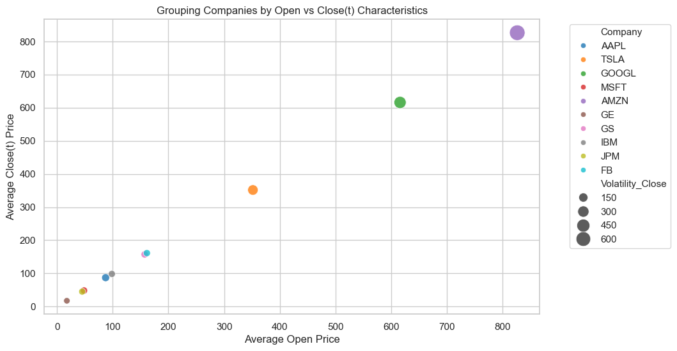
Insight:
Companies cluster by price behavior — large bubbles indicate volatile, high-risk firms (like TSLA), while smaller bubbles mark steady performers (like JPM or GE). Shows risk-return segmentation across the market.

Q35: How have average volatilities evolved across companies which show rising or declining risk levels over time?

vol_yearly = pd.DataFrame()
for c, df in data.items():
tmp = df[['Date', 'SD20']].copy()
tmp['Year'] = tmp['Date'].dt.year
yearly = tmp.groupby('Year')['SD20'].mean().rename(c)
vol_yearly = pd.concat([vol_yearly, yearly], axis=1)

vol_yearly = vol_yearly.sort_index()
print("\nQ36: Yearly average SD20 (sample):")
print(vol_yearly.tail(5).round(4))

plt.figure(figsize=(12,6))
for c in vol_yearly.columns:
plt.plot(vol_yearly.index, vol_yearly[c], marker='o', label=c, linewidth=1)
plt.title("Yearly Average Volatility (SD20) by Company")
plt.xlabel("Year")
plt.ylabel("Average SD20")
plt.legend(ncol=2, fontsize='small')
plt.grid(True)
plt.show()

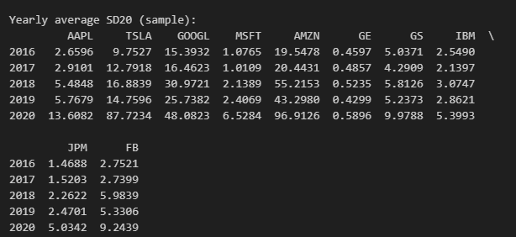
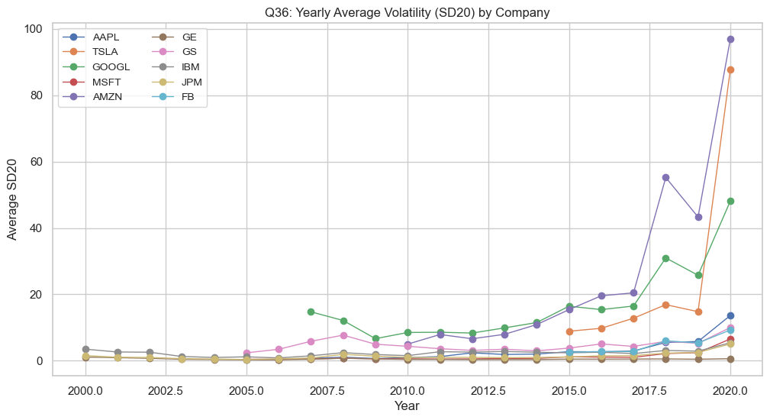

Insight:
Tracks how volatility evolved yearly. Companies with rising lines faced increasing uncertainty; declining lines show growing market stability.

Q36. Which company experiences the strongest relationship between trading volume (Volume) and volatility (SD20)

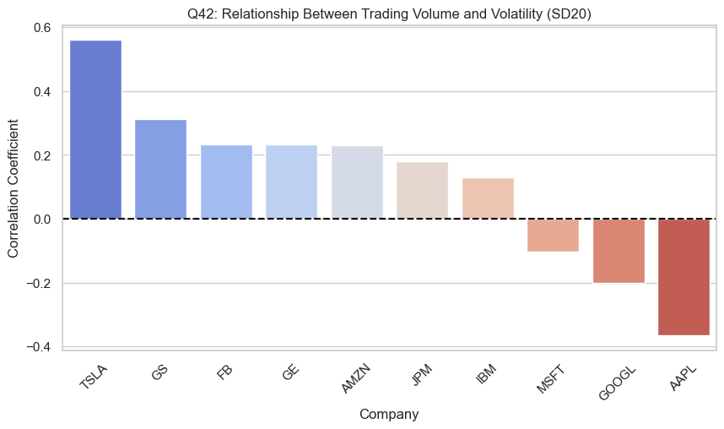

vol_vol_corr = {}

for c, df in data.items():
if 'Volume' in df.columns and 'SD20' in df.columns:
corr = df['Volume'].corr(df['SD20'])
vol_vol_corr[c] = corr

corr_df = pd.DataFrame(list(vol_vol_corr.items()), columns=['Company', 'Volume-Volatility Corr'])
corr_df = corr_df.sort_values(by='Volume-Volatility Corr', ascending=False)

plt.figure(figsize=(10,5))
sns.barplot(x='Company', y='Volume-Volatility Corr', data=corr_df, palette='coolwarm')
plt.title("Q42: Relationship Between Trading Volume and Volatility (SD20)")
plt.ylabel("Correlation Coefficient")
plt.xlabel("Company")
plt.xticks(rotation=45)
plt.axhline(0, color='black', linestyle='--')
plt.show()

print("Volume–Volatility correlation by company:\n")
print(corr_df.round(3))

Insight:
Shows how trading activity relates to risk. Strong positive correlation suggests that high trading activity accompanies larger price swings common in speculative markets.

Q37: Identify which stock shows the strongest price momentum using moving average crossover analysis.
golden_counts = {}
momentum_prop = {}
for c, df in data.items():
tmp = df[['Date', 'MA50', 'MA200']].dropna().copy()
if tmp.empty:
golden_counts[c] = 0
momentum_prop[c] = np.nan
continue
ma50 = tmp['MA50']
ma200 = tmp['MA200']
cross = (ma50 > ma200).astype(int)
golden = int((cross.diff() == 1).sum())
golden_counts[c] = golden
momentum_prop[c] = (cross.sum() / len(cross)) if len(cross) > 0 else np.nan

golden_series = pd.Series(golden_counts).sort_values(ascending=False)
momentum_prop_series = pd.Series(momentum_prop).sort_values(ascending=False)

print("\nQ37: Golden cross counts (MA50 crossing above MA200) by company")
print(golden_series)

print("\nQ37: Momentum persistence (proportion of days MA50 > MA200) by company")
print(momentum_prop_series.round(4))
plt.figure()
sns.barplot(x=golden_series.index, y=golden_series.values)
plt.title("Number of Golden Cross Events (MA50 > MA200)")
plt.ylabel("Golden Cross Count")
plt.xlabel("Company")
plt.xticks(rotation=45)
plt.show()

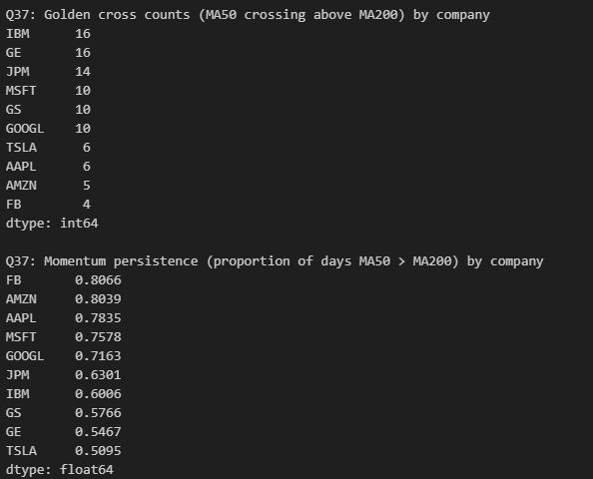

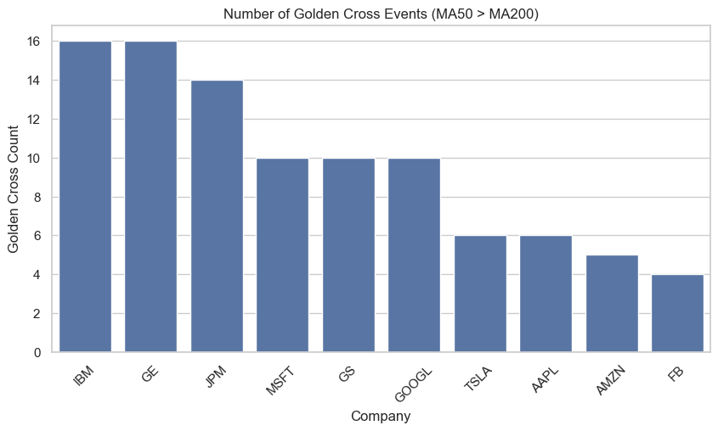

Insight:
Counts momentum crossover signals. More golden crosses = frequent bullish trends; persistent crossover dominance implies sustained upward momentum.

38. Which company’s stock is most influenced by overall market trends (S&P 500, DJIA, and QQQ)?

import numpy as np
import pandas as pd
import matplotlib.pyplot as plt
import seaborn as sns

market_influence = {}

for c, df in data.items():
cols = ['Close(t)', 'SnP_Close', 'DJIA_Close', 'QQQ_Close']
if all(col in df.columns for col in cols):
corr_snp = df['Close(t)'].corr(df['SnP_Close'])
corr_djia = df['Close(t)'].corr(df['DJIA_Close'])
corr_qqq = df['Close(t)'].corr(df['QQQ_Close'])
avg_corr = np.nanmean([corr_snp, corr_djia, corr_qqq])
market_influence[c] = avg_corr

market_df = pd.DataFrame(list(market_influence.items()), columns=['Company', 'Market_Correlation'])
market_df = market_df.sort_values(by='Market_Correlation', ascending=False)

plt.figure(figsize=(10,5))
sns.barplot(x='Company', y='Market_Correlation', data=market_df, palette='viridis')
plt.title("Company Correlation with Major Market Indices (S&P 500, DJIA, QQQ)")
plt.ylabel("Average Correlation")
plt.xlabel("Company")
plt.xticks(rotation=45)
plt.axhline(0, color='black', linestyle='--')
plt.show()

print("Average correlation of company closing prices with major market indices:\n")
print(market_df.round(3))

Insight:
Measures how sensitive each stock is to the overall market. High correlation = moves with the market; low correlation = defensive stock, useful for diversification.

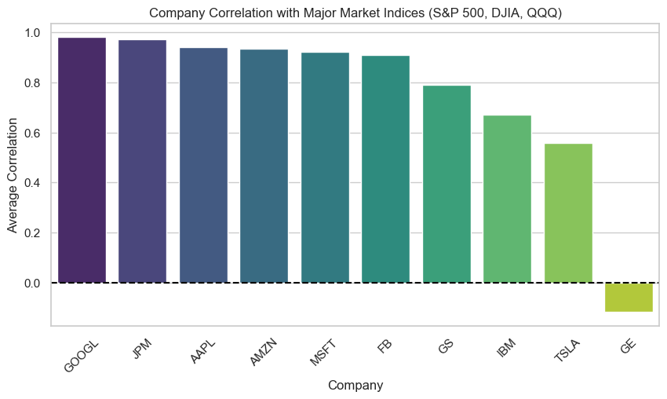

Insight:
Measures how sensitive each stock is to the overall market. High correlation = moves with the market; low correlation = defensive stock, useful for diversification.

39. Which company’s returns are most sensitive to changes in volume?

sensitivity = {c: data[c]['ROC'].corr(data[c]['Volume']) for c in data}
plt.bar(sensitivity.keys(), sensitivity.values())
plt.title('Return Sensitivity to Volume Changes')
plt.ylabel('Correlation (ROC vs Volume)')
plt.xticks(rotation=45)
plt.show()

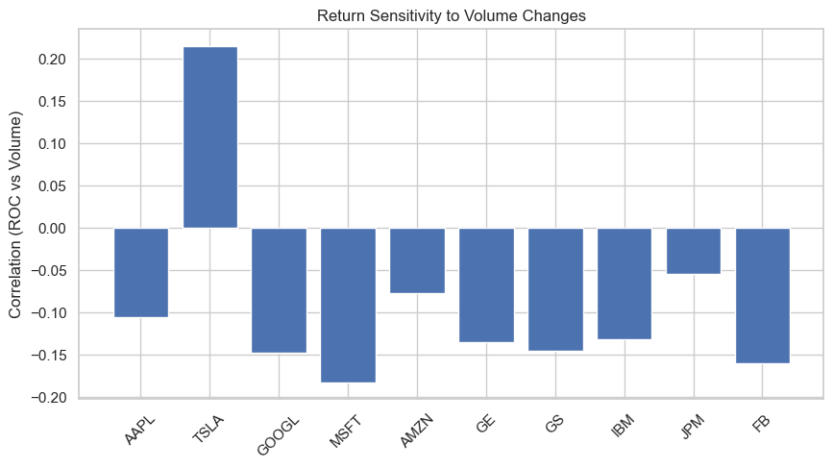
Insight:
Evaluates how much daily returns depend on volume changes. High sensitivity shows speculative or momentum-driven behavior; low indicates fundamental price stability.

40. Compare average ADX, RSI, and CCI values across companies which shows strongest market momentum and stability?

summary = pd.DataFrame({
'ADX': [data[c]['ADX'].mean() for c in data],
'RSI': [data[c]['RSI'].mean() for c in data],
'CCI': [data[c]['CCI'].mean() for c in data]
}, index=data.keys())

summary.plot(kind='bar', figsize=(10,5))
plt.title('Comparative Indicator Strength (ADX, RSI, CCI)')
plt.ylabel('Average Value')
plt.xticks(rotation=45)
plt.show()

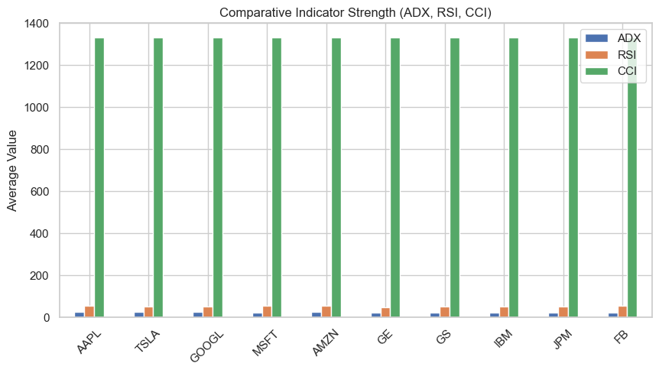

Insight:
Compares technical indicators for trend strength (ADX), momentum (RSI), and market cycles (CCI). High ADX + RSI = strong, stable upward momentum; lower CCI = sideways or corrective markets.

